Configuring Trello Tokens

1. Sign up to the service via <https://trello.com/> and follow the steps to create a workspace
2. Go to <https://trello.com/app-key> and accept Trello Developer Terms:   
   Graphical user interface, text, application

   Description automatically generated
3. Click ‘Show API Key’. You will now be able see the **api_key:**

1. Scroll down the page and save the  **API-secret:**Table

   Description automatically generated
2. 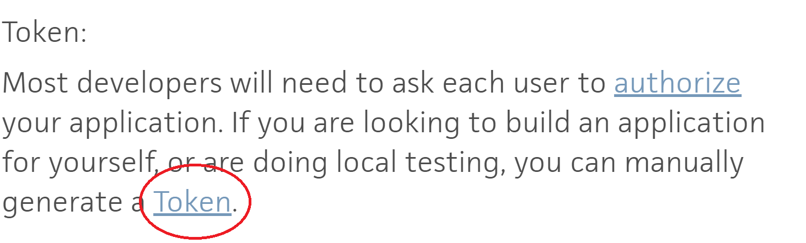Generate a Token:
3. Allow access to your workspace:   
   Graphical user interface, text, application, email

   Description automatically generated
4. This will transfer you to the **Trello Token**:   
   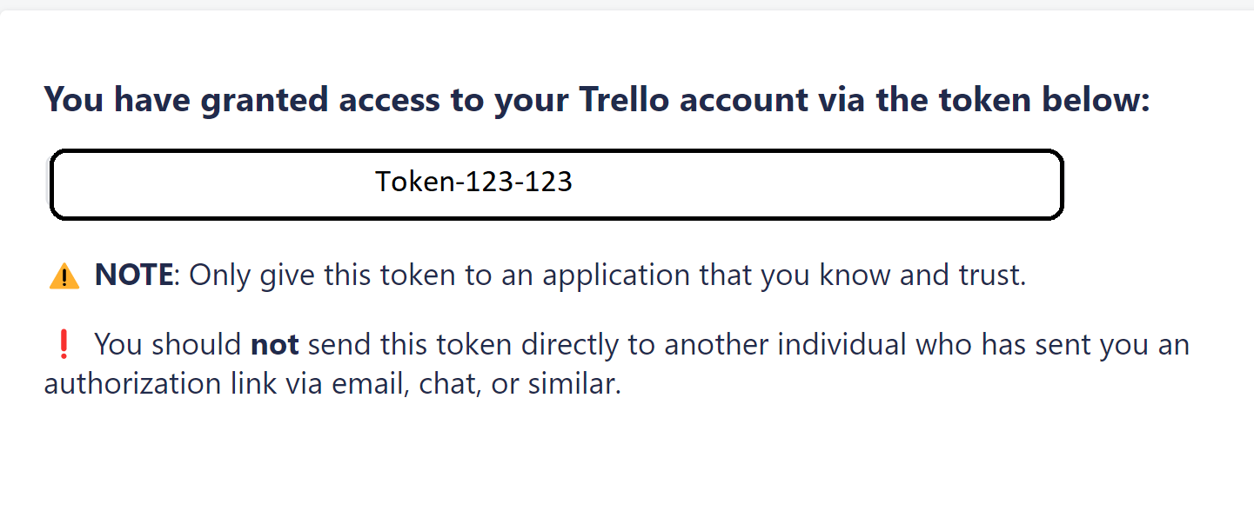
5. Register to Eevee Using the 3 keys: **API-key, API-secret, Trello Token**